

march-24



Design of a Satellite Platform Based on AMSAT V.1.3.2 for the Study of Sustainable Mobility.

**Design of a Satellite Platform Based on AMSAT V.1.3.2 for the Study of Sustainable Mobility.**

**FINAL THESIS PROJECT**

Submitted in fulfillment of the requirements for the Degree in Telecommunication Systems Engineering

by

**Juan Lacosta Arpide**

Under the supervision of

**Daniel Valderas**

Juan Lacosta Arpide

Donostia-San Sebastián, March 2025



**Final Thesis Project**

**TELECOMMUNICATION SYSTEMS ENGINEERING**

|  |
| --- |
| **Design of a Satellite Platform Based on AMSAT V.1.3.2 for the Study of Sustainable Mobility.** |

|  |
| --- |
| Juan Lacosta Arpide  Donostia-San Sebastián, February de 2025 |

Pº Manuel Lardizabal, 13. 20018 Donostia-San Sebastián, Gipuzkoa Tel. 943 219 877 · Fax 943 311 442 · www.tecnun.es

**INDEX OF CONTENTS**

INTRODUCTION

OBJECTIVES (parte academica -> un inicio para dar lugar a proyectos y que los alumnos conozcan la tecnología satélite)

STATE OF ART

HARDWARE

SOFTWARE

FEASIBILITY STUDY

BUDGET

REFERENCES

ANNEX

**INDEX OF CONTENTS**

1. INTRODUCTION AND OBJECTIVES V

1.1. Background V

1.2. AMSAT VI

1.3. Objectives VI

2. HARDWARE VII

2.1. Main Boards VII

2.1.1. Solar Board VII

2.1.2. Battery Board VIII

2.1.3. STEM Payload Board IX

2.2. Structure XIII

3. SOFTWARE XVII

3.1. Software Installation XVII

3.1.1. Creation and flashing the Raspberry Pi Image XVII

4. REFERENCES XXII

INTRODUCTION AND OBJECTIVES

* 1. Background

CubeSats[1] are small modular cube satellites with 10 cm sides and with a mass up to 1.33 kg. They were developed in 1999 by the Cal Poly (California Polytechnic State University) and the Stanford University with the goal of enabling universities worldwide to develop and execute space science research projects, which can be built from an office desk. It helped, universities, colleges and small enterprises to experiment with aerospace systems and technology at a very low cost. Some of its functionalities are[2] earth remote sensing, space exploration, and rural connectivity, among others.

This new and cheap space technology has been revolutionary. By 2004 CubeSats could be built and launched into space at a cost of approximately $65.000-80.000 and by 2008 approximately 75 CubeSats were already orbiting the earth. This drastically reduced price, compared to traditional satellite launches, established CubeSats as an affordable and viable option for academic use. The lower cost also allowed developers to introduce new technologies into space through the CubeSat, as such risk were out of reach due to their expensive cost[3].

Firstly, CubeSats were designed with basic functionalities, however, the latest’s models carry high quality sensors, cameras and can have extremely large communication links. Furthermore, some problems such as noise (SNR) which were significant at the beginning, now with new implementations have been greatly reduced resulting on better transmission, reception and processing of data. Actually, thanks to its design the whole process of building, testing and launching a CubeSat into the space can be done in a period of just 6-12 months[4]. Since launching an object into space is very expensive, important primary missions are used to include secondary payloads, such as CubeSats, without increasing fuel consumption or complicating the journey. This significantly reduces the launch cost.

In 2018 the Mars Cube One (MarCO)[5], was the first mission along with NASA's InSight Mars Lander to create a CubeSat capable of operating beyond Earth's orbit on interplanetary missions. The mission of this CubeSat was to provide real-time data transmission while the InSight lander performs the entry, descend and landing phase. This will provide unique data outside the Earth’s orbit at a faster rate, instead of waiting for several hours. Later on, more missions have been made that consisted of launching several CubeSats at the same time, each one with different functions in order to obtain more information from space and carry out different objectives. Nowadays, some enterprises such as Planet Labs, OneWeb, Spire Global,  SatRevolution and even NASA have already launched a lot of CubeSats into the space for their own interests.

* 1. AMSAT

AMSAT[6] is a group of Amateur Radio Operators with an interest in building, launching and then communicating with each other through non-commercial Amateur Radio Satellites such as CubeSats. It has had a huge impact on space-based amateur radio.

It was founded in 1969 by a group of amateur radio enthusiasts whose goal was to create satellites capable of communicating via space-based platforms. “OSCAR 1”[7] (Orbiting Satellite Carrying Amateur Radio) launched in 1961, is the first well-known satellite developed by a group of volunteers (then called AMSAT). This satellite was a rectangular box of 30 x 25 x 12 cm and weight 10 kg and was launched as a secondary payload. Its purpose was to demonstrate that satellites could be used for amateur radio communication. Then, AMSAT continued building satellites following OSCAR’s characteristics. As technology and knowledge of this nano satellites advanced, AMSAT’s satellites became more complex and offered better communication capabilities.

As CubeSats were developed in the late 1990s, on the 2000s, AMSAT began to investigate on adapting these smaller, cost-effective satellites for their missions, which marked a turning point for them and gained popularity. This led the enterprise to launch even more cost-effective and accessible satellites for amateur operators. Modern AMSAT satellites include technologies such as software-defined radio (SDR), which allows frequency and communication modes to be adjusted in real time. This enables amateur operators to use AMSAT satellites in a flexible and effective way.

* 1. Objectives

The aim of this project is to

HARDWARE

The Cubesatsim consists of different pieces such as: three main boards, two raspberry pi, solar panels, antennas, batteries and other soldered components to the boards. In this section those components and pieces are going to be explained.

* 1. Main Boards

These three boards consist of: the STEM Payload Board, Battery board and Solar Board.

The energy flow and functioning of the Cubesatsim is the following:

Firstly, the solar board generates and manages energy from sunlight. Then, this energy is regulated and used to charge the batteries of the second board, which purpose is to store and distribute it through the rest of the system. Last board, the STEM payload receives that energy from the battery board to operate sensors, read data, process it and send it to the base station.

So, to build the Cubesatsim, the three main boards were bought and received as shown in Figure XXXX.

*Figure XXXX: Battery board, STEM payload board and solar board from left to right.*[8]

Then, the next step is to buy and weld the different components to each of the boards. Therefore, in the next subsection, the boards are going to be built.

* + 1. Solar Board

The Solar Board, as explained before has a crucial role in the Cubesatsim. The solar panels situated on the Cubesatsim sides convert sunlight into electricity. The board features a regulation circuit which stabilizes the voltage and then charges the batteries of the battery board.

In order to build the Solar Board, the following components are needed:

|  |  |  |
| --- | --- | --- |
| **Component** | **Quantity** | **Location** |
| IN5817 diode | 6 | Top |
| 4.7k resistors | 2 | Top |
| 20x2 female GPIO header non-stacking | 1 | Bottom |
| Blue INA219 High Side DC Current Sensor Breakout - 26V ±3.2A Max | 6 | Top/Bottom |
| Micro JST 2 pin connectors | 14 | Top |
| QWICC connector | 1 | Top |
| 1x4 male breakaway header | 1 | Top |
| JST jumper cable | 1 | Top |

Table XXX: Solar Board components.

After soldering the components to the board, this should look like this:

Figure XXXX: Solar Board completely built.

* + 1. Battery Board

The purpose of the Battery Board is to store and manage the energy generated by the Solar Board. It contains three rechargeable AA 2500mAh batteries that store this energy. When the CubeSat Sim’s solar panels are unable to generate electricity (e.g., shadow or darkness), the stored energy in the batteries becomes the primary power source, ensuring continuous operation of the Cubesatsim.

During normal operation, the Battery Board continuously supplies power to the STEM Payload Board. This allows sensor data processing, communication tasks, and other mission operations. In turn, this energy is used to ensure the proper functioning of all Cubesatsim systems, including data transmission via radiofrequency. By effectively managing energy storage and distribution, the Battery Board plays a crucial role in maintaining the CubeSat Sim’s functionality throughout all the time.

The components needed to solder are the following:

|  |  |  |
| --- | --- | --- |
| **Component** | **Quantity** | **Location** |
| 1 cell AA battery holder 1024 | 1 | Top |
| 2 cell AA battery holder 1012 | 1 | Top |
| Blue INA219 High Side DC Current Sensor Breakout - 26V ±3.2A Max | 1 | Bottom |
| GPIO 20x2 female stacking header extra-long pins | 1 | Bottom |
| Micro JST 2 pin connectors | 1 | Top |
| AA 2500mAh NiMH Rechargeable Battery 4 pack | 1 | Top |
| Dual battery clip | 1 | Top |
| Single battery clip | 1 | Top |
| JST jumper cable | 1 | Top |

Table XXX: Battery Board Components.

The next step is to solder the components to the board having as a result the following board:

Figure XXXX: Battery Board completely built.

* + 1. STEM Payload Board

The aim of this board is to oversee all the reading, processing and transmission of data to ensure the proper functioning of the Cubesatsim. The STEM payload board features a Raspberry Pi Pico as its microcontroller which facilitates the management and the programming of all that data. Additionally, it employs various communication protocols, such as I2C, to connect the board with the sensors, and then uses UART to send the data to the Raspberry Pi. The Raspberry Pi, which contains the necessary software and programming, subsequently processes and transmits the data via radio frequency, as will be explained later. Furthermore, the board contains a high-frequency (UHF) radio transceiver (SR105U) that operates at 400-480MHz. It incorporates a high-performance RF transceiver chip, a microcontroller, and an RF power amplifier. This module is suitable for long-distance data transfer and wireless communications. Communication with an external controller is done through UART.

Therefore, the components needed are the following:

|  |  |  |
| --- | --- | --- |
| **Component** | **Quantity** | **Location** |
| GPIO 20x2 female stacking header extra-long pins | 1 | Bottom |
| Pushbutton switch, SPST RA-SPST | 1 | Top |
| SC1464-ND 3.50mm Headphone Phone Jack Stereo (3 Conductor, TRS) for RBF switch | 1 | Top |
| 1k Ohm resistor | 1 | Top |
| Green LED | 1 | Top |
| 220 Ohm resistor | 1 | Top |
| Red LED | 1 | Top |
| 100 Ohm resistor | 1 | Top |
| Blue LED | 1 | Top |
| IN5817 diode | 2 | Top |
| 68 Ohm resistor, 1/2 W | 2 | Top |
| 180 Ohm resistor | 1 | Top |
| Raspberry Pi Pico WH | 1 | Top |
| USB-C cable and power plug | 1 | Side |
| RBF keychain | 1 | Side |
| 3.5mm plug | 1 | Side |
| 47uF electrolytic capacitor | 1 | Top |
| 100nF capacitor | 1 | Top |
| 220 Ohm resistor | 1 | Top |
| 100 Ohm resistor | 1 | Top |
| 20 pin female sockets for Pico | 2 | Top |
| 4.7k resistor | 2 | Top |
| MPU6050 9 Axis Gyro GY-521 | 1 | Top |
| Female 1x8 header | 1 | Top |
| BME280 Board Temperature/Humidity/Pressure | 1 | Top |
| Female 1x4 header | 1 | Top |
| 10k resistor | 1 | Top |
| 100nF capacitor | 1 | Top |
| 1N5817 diode | 1 | Top |
| 1N4148 diode | 1 | Top |
| JST 2.0 connector | 1 | Top |
| Yellow LED | 1 | Top |
| 1k resistor | 1 | Top |
| White LED | 1 | Top |
| 1k resistor | 1 | Top |
| QWICC connector | 1 | Top |
| 1x4 male breakaway header | 1 | Top |
| 2.5mm audio jack | 1 | Top |
| SMA vertical female connector | 2 | Top |
| SMA 6" male to female for antenna connection | 2 | Top |
| SMA 433 MHz antenna | 2 | Top |

Table XXX: STEM Payload Board components.

Then, after welding each component and adding the antennas, the final STEM Payload Board should look like in the next *Figure XXXX*.

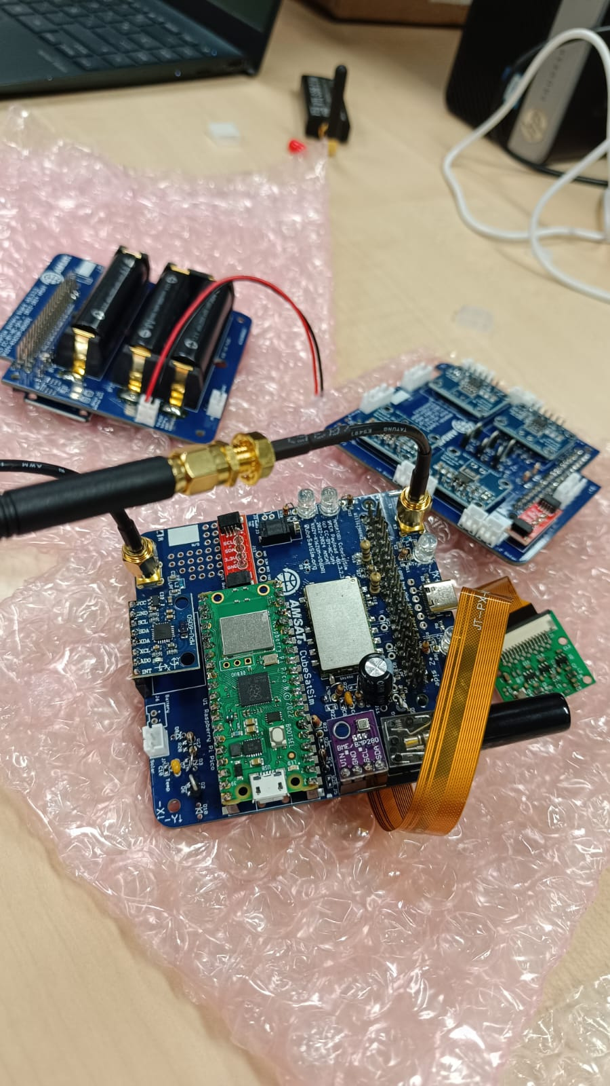

Figure XXXX: STEM Payload Board completely built.

After building the board, a correct functioning test must be done. To do so, the Raspberry Pi Pico must be connected to the base computer with micro usb wire. After reading data from Arduino IDE, this should appear with real values when transmitting:

Figure XXXX: Sensor data read from Raspberry Pi Pico.

On the image above, the different sensors of the board are transmitting data. The BME280 is an environmental sensor developed by Bosch Sensortec capable of measuring temperature (ºC), pressure (hPa), altitude (m, derived from pression) and humidity (RH).

On the other hand, the MPU6050 is a 6-axis motion tracking sensor developed by InvenSense. It combines a 3-axis accelerometer and a 3-axis gyroscope in a single chip, which makes it ideal for this type of application. The accelerometer measures linear acceleration along X, Y and Z axis while the gyroscope measures the angular velocity (rotation) around the same axes. Both sensors use I2C protocol for easy communication with the raspberry.

Lastly, the GPS data appears as null. This is because the STEM Payload Board does not yet include a GPS sensor. However, a GPS module is already configured in the software code, allowing for future integration.

After this, the board is correctly configured and ready to be used.

* 1. Structure

Once the three main boards are completely configured and tested, the structure of the Cubesatsim must be assembled. The following components are required:

|  |  |
| --- | --- |
| **Structure** | |
| **Component** | **Quantity** |
| Battery Board fully assembled | 1 |
| STEM Payload Board fully assembled | 1 |
| Solar Board fully assembled | 1 |
| GPIO 20x2 female stacking header extra-long pins | 2 |
| M2.5 screws | 8 |
| M2.5 23mm + 6mm standoff | 8 |
| M2.5 11mm standoff | 2 |
| M2.5 18mm standoff | 2 |
| M2.5 6mm + 6mm standoff | 2 |
| USB Sound Card | 1 |
| OTG cable for Sound Card | 1 |
| 2.5mm to 3.5mm jumper cable | 1 |
| 3D Printed Frame (4 parts) | 1 |
| Nylon M3 screws for frame | 10 |
| Nylon M3 nuts for frame | 10 |
| Slotted nylon M2 screws for camera | 4 |
| Nylon M2 nuts for camera | 4 |
| Solar Cells | 10 |
| Micro JST wires | 10 |
| Pi Zero 2 with SD card | 1 |
| Pi Camera with Pi Zero ribbon cable | 1 |

Table XXX: Structure components.

Firstly, each Micro JST wire needs to be soldered to the solar panels, (see Figure XXXX). Then, the camera module should be connected to the Raspberry Pi Zero using the ribbon cable.

The three main boards must be stacked and secured with screws in the following order: Solar Board on top, STEM Payload Board in the middle, and Battery Board at the bottom. The Raspberry Pi Zero, along with the camera, should be positioned at the bottom of the Battery Board (see Figure XXXX).

Figure XXXX: Camera and Raspberry Pi Zero.

JST wires are used to establish the connection between the boards. In order to integrate the USB sound card, the following two steps are needed to follow: connect the OTG cable for USB sound card to the Raspberry Pi Zero. Then, a jumper cable links the USB sound card to the STEM Payload Board. This configuration allows the Battery Board (responsible for power management) to interface with the STEM Payload Board (which processes sensor data and transmits it).

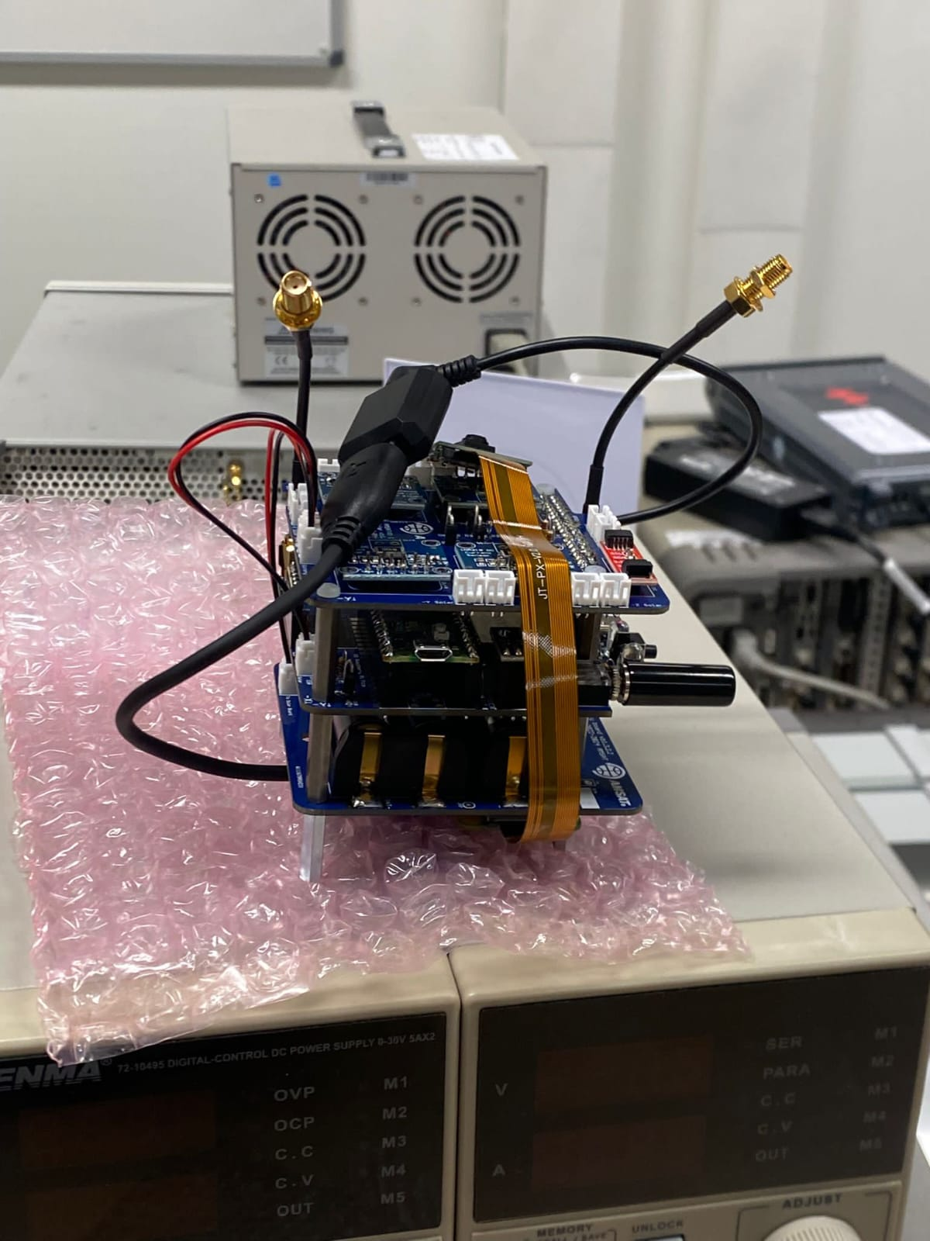

Figure XXXX: Three boards connected and built.

The 3D-printed frames must be prepared and checked for proper fit. Once the electronic components are secured, the entire system is enclosed within the 3D-printed Cubesatsim structure, forming a complete cube. The solar panels need to be pasted with double sided tape as shown in the following pictures.

Figure XXXX: Full structure of the Cubesatsim built.

For added stability, the antennas are glued with silicone to the interior walls and a supporting stick is attached to the antennas to hold them in position and ensure structural integrity.

SOFTWARE

In this section, the installation of the software will be explained. Furthermore, the different tests done with the boards and with the telemetry will be shown below.

In order to fully understand how it works and how has been everything tested, the first step is to install the software.

* 1. Software Installation
     1. Creation and flashing the Raspberry Pi Image

Firstly, to install the necessary software for the Raspberry Pi Pico to function properly, it is necessary to clone the software files from Alan Johnson’s GitHub repository into the SD card (inside the Raspberry Pi). The materials needed to do so are the following:

|  |  |
| --- | --- |
| **Software installation** | |
| **Component** | **Quantity** |
| USB-C cable and power plug | 1 |
| Pi Zero WH (with pre-soldered headers) | 1 |
| 16GB micro-SD Card | 1 |
| Pico WH (with pre-soldered headers) | 1 |
| Computer with Raspberry Pi Imager program | 1 |

Table XXX: Required materials for software installation.

The first step to flash the software into the SD card is to insert the micro-SD card into a computer and run “Raspberry Pi Imager”. This program is used to write an operating system image onto the SD card, preparing it for use with the Raspberry Pi.

Figure XXXX: Raspberry Pi Imager program.

Then, the following options have to be selected: under “Raspberry Pi Device” select the Raspberry Pi Zero, for “Operating System” choose Raspberry Pi OS (Legacy, 32-bit) Lite as the operating system and under “Storage” select the micro-SD card inserted.

Figure XXXX: Options selected for the creation of the image.

When selecting “NEXT” a new window will appear. Select the option “EDIT SETTINGS” in order to apply our own configuration. These settings should look like the next image:

Figure XXXX: Image configuration settings for Raspberry Pi flashing.

Finally, in “SERVICES” enable the option “SSH” using password authentication (which will be the one specified on Figure XXXX) Then, click on “SAVE” and continue flashing all data into the micro-SD card. Once the flash is finished, remove the card from the computer and insert it into the Raspberry Pi Zero and power it to boot it up and test its functioning.

Once the Raspberry Pi has booted up, if it has been properly enabled, a connection between a computer and the raspberry can be established. The Raspberry Pi should automatically connect to the previously configured Wi-Fi network. The computer must be connected to the same Wi-Fi network. Then, in the Terminal Window or Windows Command Prompt, you can type the next command to log in into the raspberry:

*ssh pi@cubesatsim.local* (being “cubesatsim” the hostname defined before)

The first time you log onto the raspberry, this question will appear: *“Are you sure you want to continue connecting (yes/no/[fingerprint])?”*: type “yes”. At the password prompt, type the password defined before (on the image configuration settings). Finally, the raspberry and the computer should be connected, and the interface must be the following:

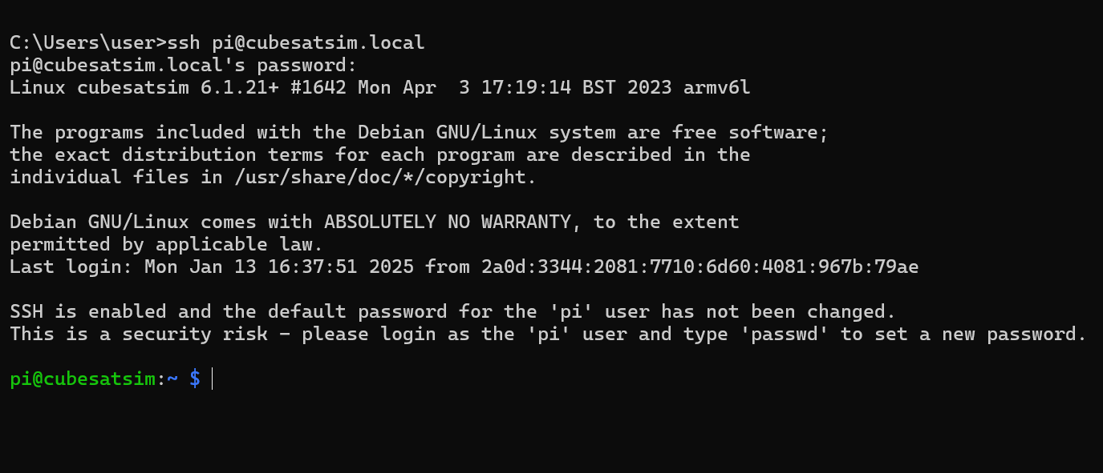

Figure XXXX: SSH interface once it is connected.

At this point, the base station (computer) can access files and data stored in the Raspberry Pi. Once SSH access to the Raspberry Pi Zero has been established, the next step is to install the Cubesatsim software.

The first task is to ensure that the Raspberry Pi is connected to the Internet. This can be verified by executing the following command in the terminal:

*timeout 10 ping amazon.com*

If the response includes messages such as "64 bytes received", this means that the device is successfully connected to the network. If not, the Wi-Fi connection should be checked. Once the Internet connection has been confirmed, the following commands must be executed in the terminal to update the system and install the necessary tools:

*sudo apt-get update && sudo apt-get dist-upgrade -y*

*sudo apt-get install -y git*

*git clone http://github.com/alanbjohnston/CubeSatSim.git*

*cd CubeSatSim*

*git checkout master*

After completing these steps, the CubeSatSim repository will be successfully cloned to the Raspberry Pi. To finalize the installation, the following command must be executed:

*./install*

Now the Cubesatsim is completely configured.

* 1. Ground Station

The ground station (receiving computer) for the Cubesatsim is used to receive data via Radiofrequency and decode it to see the telemetry. This section will explain the material and installations needed to be done in order to accomplish this function.

|  |  |
| --- | --- |
| **Ground Station** | |
| **Component** | **Quantity** |
| PC with RTL-SDR | 1 |
| SMA Antenna for 433 MHz right angle | 1 |

Table XXX: Material needed to configure the Ground Station.

To receive the radio transmission, it is needed to use the RTL-SDR. This radio receptor allows us to receive and process radio signals in a range of frequencies. Normally 500 kHz hasta 1.75 GHz. In this case, around 434.9MHz which will be the transmitting frequency. It works as a radio scanner capable of receiving signals without a specific hardware or software. With a compatible program with the RTL-SDR, the data received can be well decoded.

1. REFERENCES

<https://es.wikipedia.org/wiki/CubeSat>

<https://www.cubesat.org/about>

<https://webcitation.org/6ABSpR8qR?url=http://www.cubesat.org/images/developers/cds_rev12.pdf>

1. <file:///C:/Users/CUBESAT/Downloads/MEMORIA%20v2.pdf>
2. <https://ieeexplore.ieee.org/stamp/stamp.jsp?tp=&arnumber=9079470>
3. <file:///C:/Users/CUBESAT/Downloads/An_Overview_of_Software-Defined_Radio_Technology_i.pdf>
4. <https://www.infoespacial.com/texto-diario/mostrar/3572586/cubesats>
5. <https://es.wikipedia.org/wiki/Mars_Cube_One#:~:text=Mars%20Cube%20One%20(o%20MarCO,Mars%20Lander%20de%20la%20NASA>.
6. <https://www.amsat.org/amsat-history/>
7. <https://en.wikipedia.org/wiki/OSCAR_1>
8. <https://www.amsat.org/amsat-cubesatsim-beta-release-v1-3/>